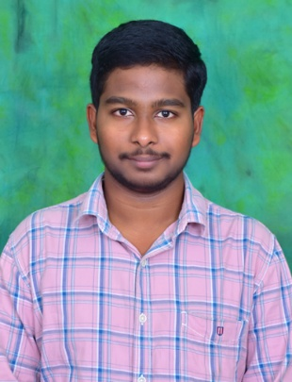

**KUMAR GUPTA MATTAPARTHI**

Mobile :+919542943919

Email : mattapartikumargupta@gmail.com

Address : Door No: 2-34 ,Kandriga Grama

Panchayat street, Kandriga, Kothapeta Mandal, East Godavari

District, Andhra Pradesh,533229

**CAREER OBJECTIVE:**

Seeking an entry-level position to begin my career in a reputable organization to expand my Learnings,

Knowledge and Skills.

**EDUCATIONAL QUALIFICATIONS:**

|  |  |  |  |  |
| --- | --- | --- | --- | --- |
| COURSE | INSTITUTE | UNIVERSITY/BOARD | CGPA | YEAR OF PASSING |
| B.Tech  (Electronics and communication engineering) | Srinivasa institute of engineering and technology, CHEYYERU | Jawaharlal Nehru Technological University ,Kakinada | 7.2 | 2024 |
| Intermediate | Sri Chaitanya junior college,  Poranki, VIJAYAWADA | Board of Intermediate  Education Andhra Pradesh | 9.25 | 2020 |
| SSC | Bhashyam (E.M) High School, KOTHAPETA | Board of secondary school  Education | 9.7 | 2018 |

**TECHNICAL SKILLS:**

**Programming Languages :**C,PYTHON

**Tools :**MS office Tools.

**ONLINE CERTIFICATION COURSES:**

* Pursued **JAVA FULL STACK MASTER CLASS** Online course Certification Course offered by the **PANTECH E LEARNING** in September 2022.

**STRENGTHS:**

* Self confidence
* Quick learner
* Hard working
* Team Leading

**ACHEIVEMENTS:**

* Secured FIRST PRIZE in 28th National Mathematics Talent Search Competition -2017
* Participated and Certified in the SOF National science Olympiad, held during November 2017
* Participated and Certified in the SOF International Mathematics Olympiad ,held during December 2017

**PROJECT:**

I have Worked on Community service Project on WATER FACILITIES AND DRINKING WATER AVAILABILITY in the academic Year 2022.

**PERSONAL INFO:**

Father name : Durga Venkata Prasad Mattaparthi

Mother name. : Durga Mattaparthi

Date of Birth. : 12-06-2002

Gender : Male

Languages known : Telugu,English and Hindi

**DECLARATION:**

I here by declare that information furnished above is true and to the best of my knowledge and belief.

**Place :** Mammidivaram

**Date. :** 06-01-2023 (**M.KUMAR GUPTA**)